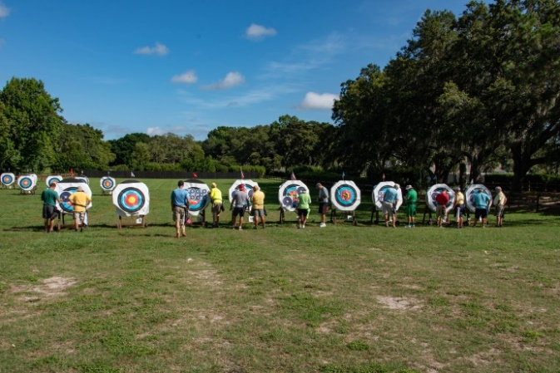

***Benefits of being a member***

* 17 covered shooting stations at both locations.
* Full access to all archery equipment and equipment can be borrowed up to 5 days
* Extensive archery library
* Experienced, qualified mentors
* Club sponsored leagues
* Holiday party
* Comradery with over 200 members
* Membership with State, Nationals and World Champions
* Facebook page
* Classified Listings

***How do I join?***

* You must be a Village resident.
* Complete a membership application. (Download from website)
* Attend a monthly membership meeting, present the application and pay the yearly dues.

***When can I shoot?***

* All new members are encouraged to attend a 2-hour, 101 class, sponsored by The Villages. Classes cover safety, range rules and archery basics. Class is free and you would register at Paradise or Fenney Rec Center. Contact the Rec Center for class schedules.

***How do I remain a Club Member in good standing?***

* Abide by all rules and guidelines set forth by the Club and Ranges.
* Exercise due diligence in the care of equipment and facilities.
* Participate in club activities. Example: Shooting, work parties, club functions, etc.
* Pay your yearly dues on time.

Dudley Range

Paradise Range

Compound or Recurve

