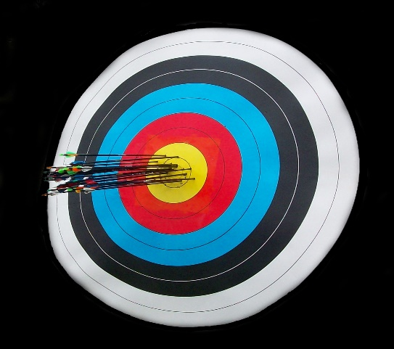

Users must be at least 13 years of age. Guests under 18 must have an adult resident with them. A valid Resident ID or guest ID is required.

***General***

The archery club has a fully equipped shop for repairing equipment and making arrows. The shop is available for member use and is located at the Paradise range.

The archery club owns several types of bows, as well as arrows and shooting accessories. Members can sign out equipment at the Paradise range for use at Paradise or Fenney range.

***Workshop***

Join

Today!

The archery club organizes a variety of shooting events throughout the year including winter and summer team league shoots. Tournaments generally are open to non-resident archers of all ages, including youths. In addition, our social committee organizes seasonal “fun shoots”. The club also provides “learn to shoot” clinics for Village residents.

*The Villages has two First   
Class Archery Ranges*

First Cl

**Dudley Range**

**2450 Fenney Drive**

**Both ranges open Dawn to Dusk**

**Paradise Range**

**1300 Paradise Drive**

Catch us on Facebook

The club is open to any resident interested in learning about the sport of archery. Both seasoned and inexperienced archers are welcome. The Villages Archery Club meets the second Monday of each month, 6 pm at the Rohan Recreation Center.

Website: [www.villagesarcheryclub.com](http://www.villagesarcheryclub.com)

Email to: [villagesarcheryclub@gmail.com](mailto:%20%20villagesarcheryclub@gmail.com)

**The Villages**

**Archery Club**

***Club Resources***

